## Figure 1 – Overview of the Magnetic Pincher steps

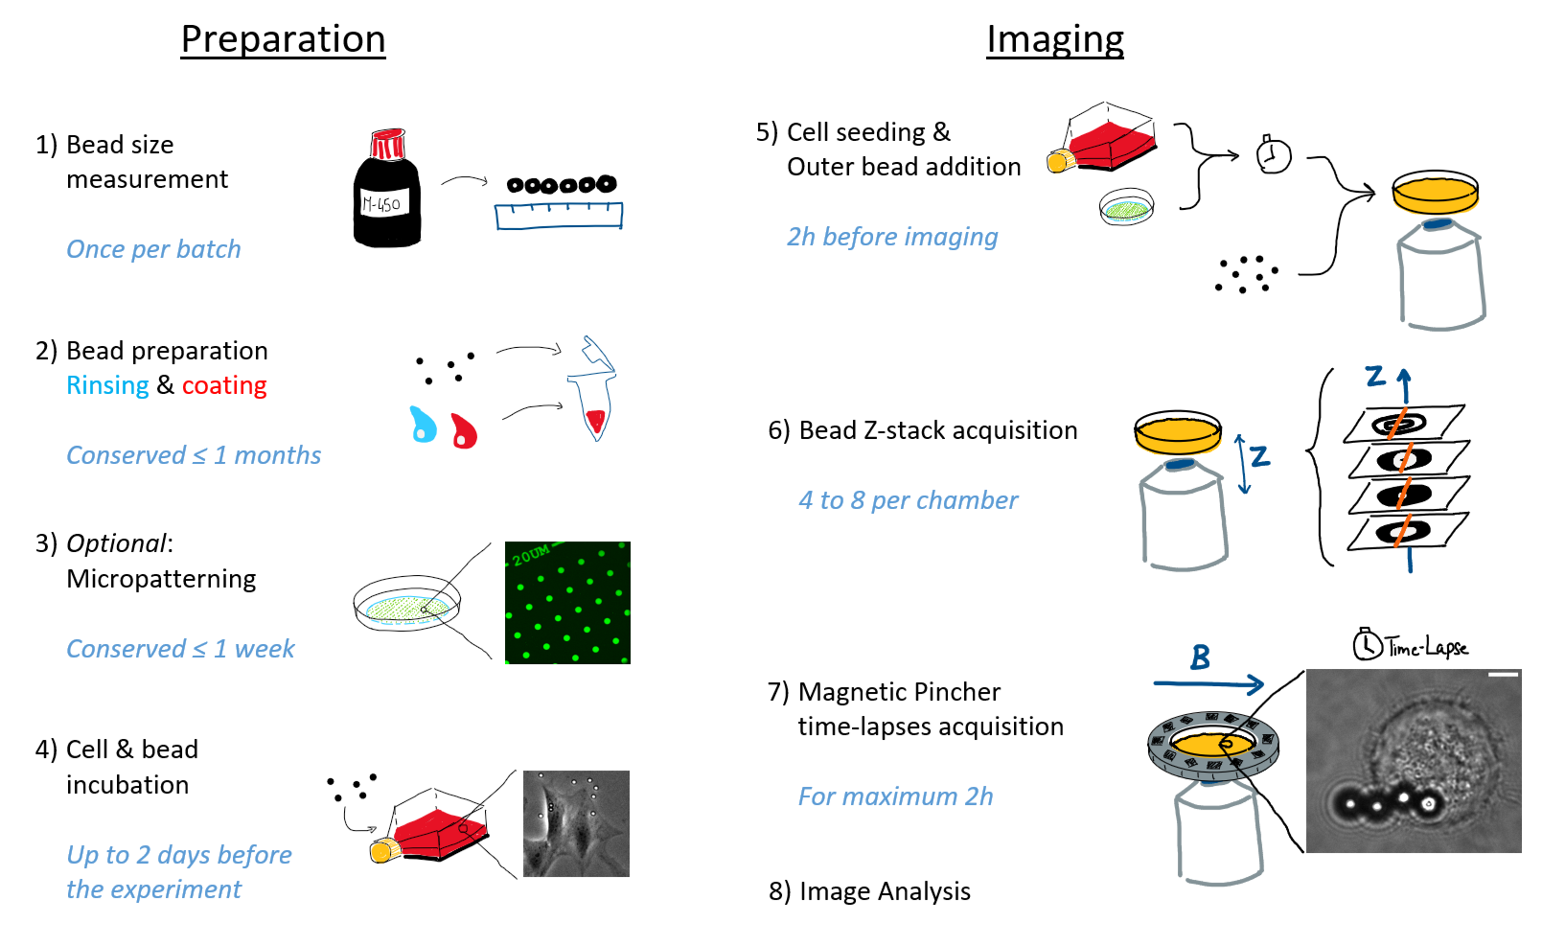

## Figure 2 – Principle of the Magnetic Pincher technique

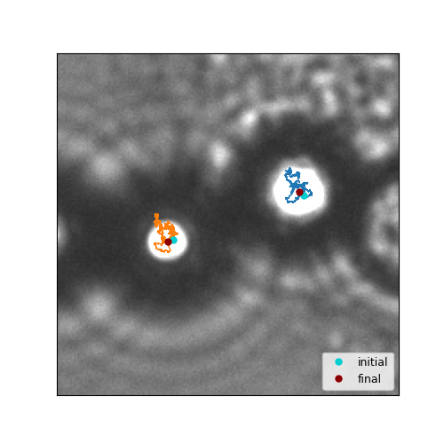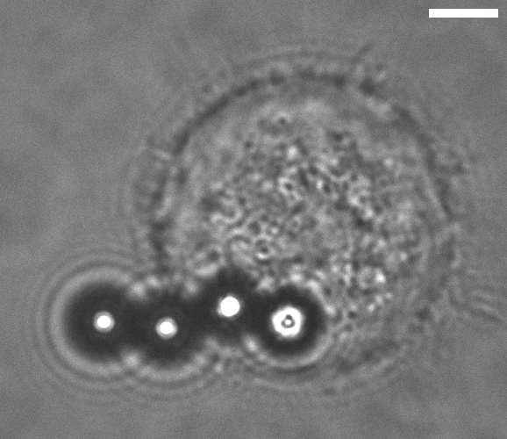

**B**

**B**

**B**

**A**

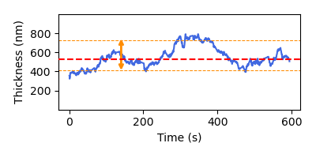

**C**

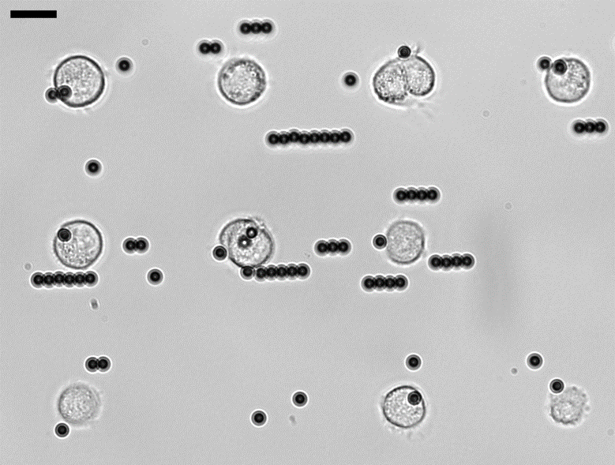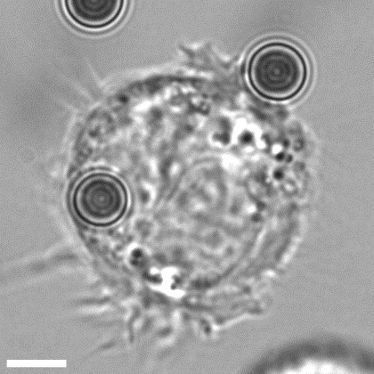

**E**

**D**

A – 3T3 fibroblast with its cortex pinched by superparamagnetic M-450 Dynabeads. The image was acquired with brightfield microscopy, objective 100X, NA = 1.4, scale bar = 5µm. The cell is adhering on a 20 µm micropatterned fibronectin disc and cannot spread more because the surrounding substrate is coated with PLL-g-PEG. The cell has ingested two beads and two outer beads have been attracted toward them, the ensemble forming a chain aligned with the magnetic field (blue arrow). The two beads in the white frame are the ones pinching the cortex. Here the focus is made on the light spot below the beads. NB: The bright spot is saturated in this image for better visualization, but should not be saturated during the course of the experiment. B – A zoom on the region marked by the white frame, scale bar = 5µm. The trajectories of the beads within a 10 minute long observation are shown in orange and blue. C – Cortical thickness as a function of time (blue line) for this 3T3 fibroblast. The median (red dashed line) and the inter-decile difference (D9 - D1, orange lines and arrow) are the metrics used to characterize respectively the typical cortical thickness and the fluctuation amplitude. Here the median is 525 nm and the fluctuations amplitude 320 nm. D – A larger field of view of a Magnetic Pincher experiment, with 3T3 cells adhering on 20 µm fibronectin discs. The orange arrows point to two pinching event suitable for image acquisition. Magnification 40X, scale bar 20 µm. E – A 3T3 cell with one M-450 inside, with the focus made on the bead equatorial plane. The cell is adhering on a 20 µm fibronectin disc; scale bar 5 µm.

## Figure 3 – Halbach Array

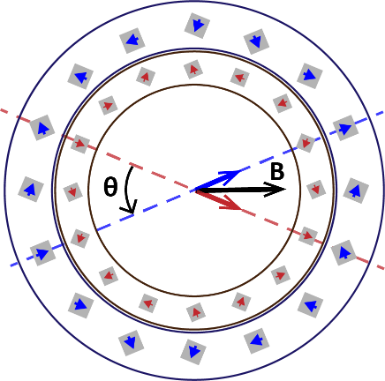

**A**

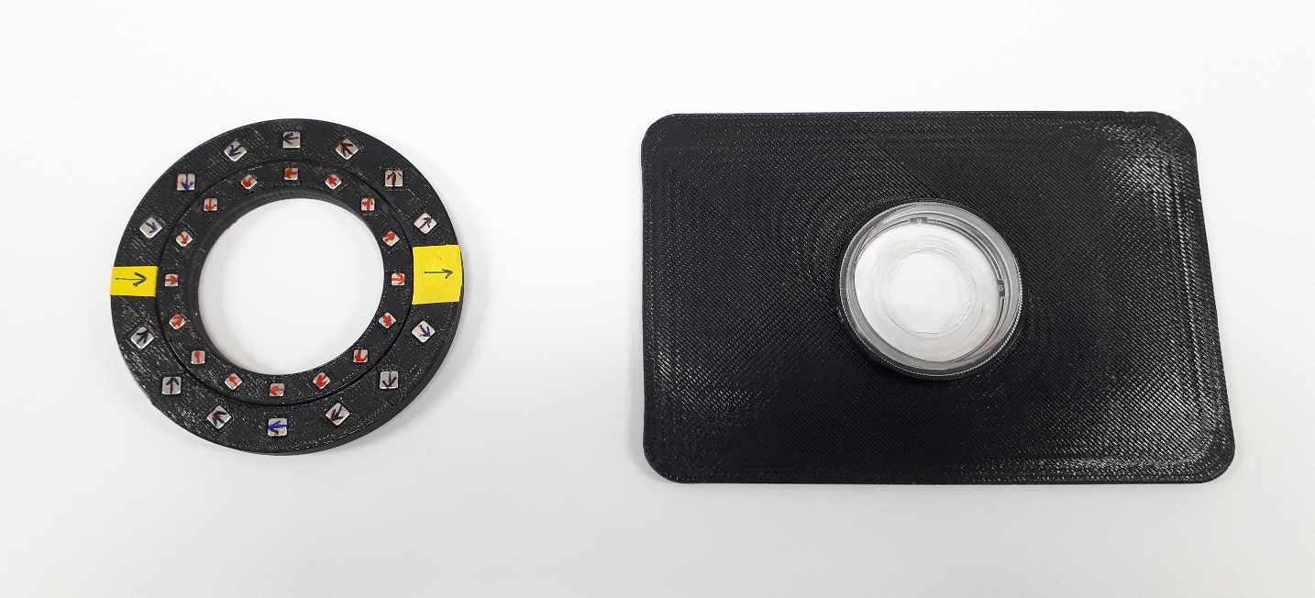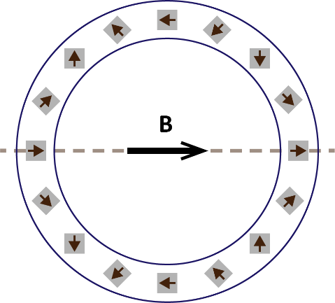

**B**

**C**

A – Schematic of a simple circular Halbach array. On the circle, the magnetic moment vectors of magnets are represented as arrows; in the center, the resulting magnetic field created inside the Halbach. Note the way magnets are arranged: as one rotate along the circle, the magnets’ moment direction rotate twice as fast. B – Schematic of nested circular Halbach arrays. The two arrays are designed to generate fields of equal magnitudes B0 (blue and red arrows in the center). The direction of this field is figured for the outer and inner arrays by the dashed lines (red and blue respectively). Rotating one with respect to another by an angle θ allow to tune the magnitude of the total field (black arrow): B = 2B0 **·** cos(θ/2). C – 3D-printed Halbach corresponding to Table 1 specifications. Right: the nested Halbach arrays. Left: The associated rectangular support which has the same outer dimensions as a 6-well plate. A central cylindrical extrusion allow to fit perfectly an experimental chamber inside (here a micropatterned chamber, see section 1.3.5) and the Halbach arrays outside.

## Table 1 – Example of nested Halbach array design – Technical specifications

|  |  |
| --- | --- |
| Support | |
| Length x Width x Thickness | 127 x 85 x 3.5 mm |
| Inner array | |
| Inner / Central / Outer radius | 21 / 24.75 / 28 mm |
| Height | 5 mm |
| Magnet side length | 3 mm |
| Number, type of magnets | 16, N42 Neodymium |
| Outer Array | |
| Inner / Central / Outer radius | 28 / 33 / 38 mm |
| Height | 5 mm |
| Magnet side length | 4 mm |
| Number / type of magnets | 16 / N42 Neodymium |
| Magnetic Properties | |
| Maximum magnetic field magnitude  (arrays in the same direction) | Ideally: 8.6 mT  Experimentally: 8.3 mT |
| Minimum magnetic field magnitude  (arrays in opposite directions) | Ideally: 0 mT  Experimentally: 0.2 mT |
| Gradient over the central 1 cm region | < 0.11 mT.mm-1 |
|  |  |

## Table 2 - Comparison of the two magnetic field generation solution

|  |  |  |
| --- | --- | --- |
|  | Halbach array | Coils |
| Fabrication | * The body can be 3D-printed * Magnets are available at low cost | * Need of a custom manufacturing |
| Size | Can be designed with the size of a 6-wells plate or a 10 cm petri dish. | Each coil is 40 x 86 mm  (length x outer diameter) |
| Mounting on a microscope | Simple, given the flexible design options. | Require a ≈ 140 x 95 mm rectangular hole in the microscope stage. |
| Generated field | With a simple array: 1 fixed field, from 1 to 90 mT.  With a nested array: tunable field, from 0 to 30 mT. The adjustments cannot be done live during an experiment. | Field adjustable in live during the experiment by tuning the intensity of the current supplied to the coils. The field can go from 0 to 60 mT, but high magnitudes cannot be maintained too long, due to the Joule effect heating the coils. |

## Figure 4 – Coils and imaging setup

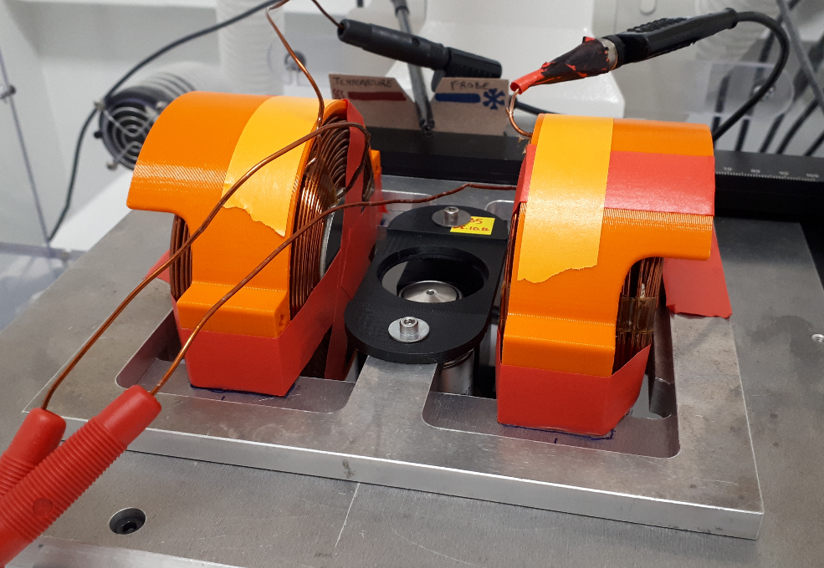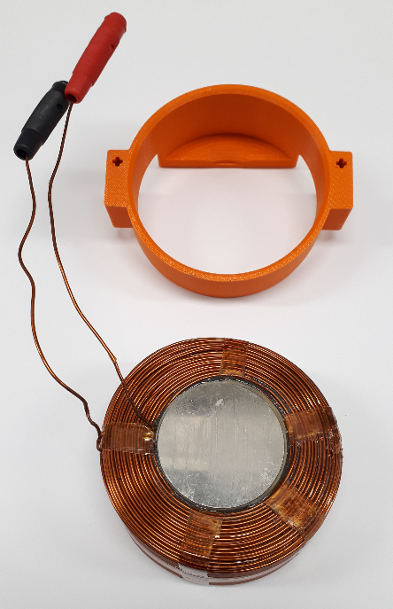

**A**

**B**

A – A coil and its case. The coil (bottom) itself is comprised of the mu-metal core, the spires, and the electric connectors. The role of the case (top) is to support the coil when it is mounted on the microscope stage. B – A pair of coils mounted on an inverted microscope stage. The coils in their cases are coaxial and equidistant from the objective. The stage comprises a rectangular hole to allow the coils to be mounted. Its mobile part is attached to an XY micromanipulator and support a 3D-printed dish-holder.

## Figure 5 – M-450 Dynabeads

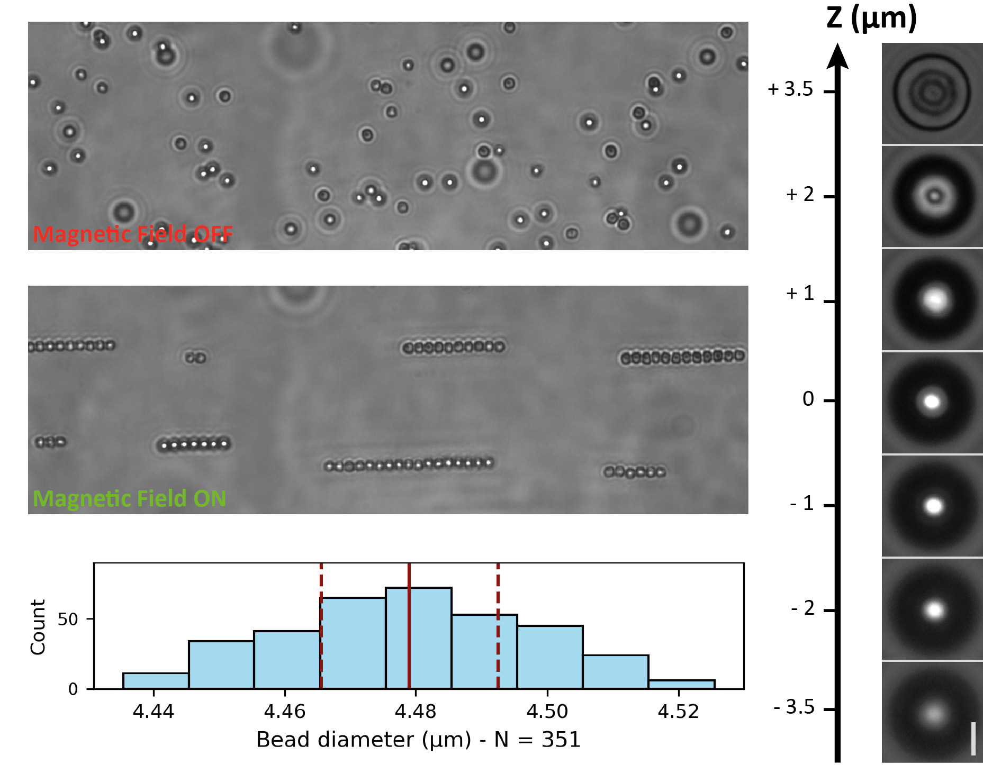

**A**

**B**

**D**

**C**

A, B – M-450 Dynabeads before (A) and after (B) exposition to an external magnetic field. Without field, the beads undergo Brownian motion. When exposed to an external field, the beads magnetize, and attract each other to form pairs or chain aligned with the field direction (horizontal here). C – Aspect of a bead along the vertical direction (scale bar: 2 µm). The zero of the Z-axis is here the plane where the light spot observed below the bead is the brightest. In planes higher or lower, the intensity decrease progressively, and the shape of the light spot changes. Here the pixel value range is the same on all the images but has been adjusted to increase the contrast. D – Histogram of the bead size distribution within one batch of M-450 Dynabeads, with a bin size of 10 nm. The red line is the median, the dashed lines are the quartiles. Over N = 351 beads, the average diameter is 4476 nm with a standard deviation of 19 nm.

## Figure 6 – Time-lapse Acquisition

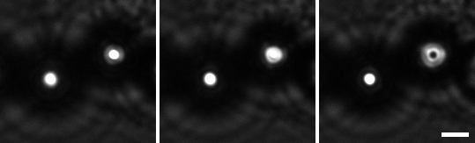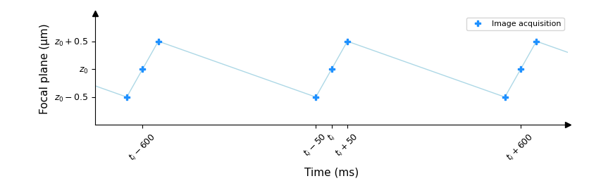

**A**

**B**

**Down**

**Mid**

**Up**

A – Acquisition scheme. For each time-point ti, a stack of three frames is acquired. Those three frames are acquired every 50 ms and are distant of 0.5 µm along the Z-axis. B – Example of such triplet of frames, taken from the same film as Fig. 1 (Scale bar: 2 µm). Note that here the two beads do not have the same Z coordinate: the left bead light spot is at its brightest in the “Up” frame, while for the right bead it is in the “Down” frame. The left bead is therefore slightly above the right bead. NB: The bright spot is saturated in this image for better visualization, but should not be saturated during the course of the experiment.

## Figure 7 – Localize bead centers with Fiji

**A**

**B**

**D**

**C**

**E**

A – Raw frame of a Magnetic Pincher time-lapse. Only the contrast have been modified. The image has no scale (results in pixel values). B – The same frame, where the threshold have been applied and a rectangular region of interest have been drawn around the beads pinching the cortex. C – The “Threshold” dialog box. It has been manually adjusted to segment properly the beads light spot in all frames of the time-lapse. D – The “Analyze Particles” dialog box. The parameters shown here are the set typically applied. E – The “Results” windows that opens after running “Analyze Particles”. The two selected lines correspond to the two light spots segmented inside the ROI in (B). The columns XM and YM contain the coordinates of the centers of mass of the light spots (center weighted by the pixel values). Note that here, running “Analyze Particles” with the option “Show: Outlines” would also open an “Outlines” window (not shown here) useful to assess the quality of the detection.

## Figure 8 – Depthograph

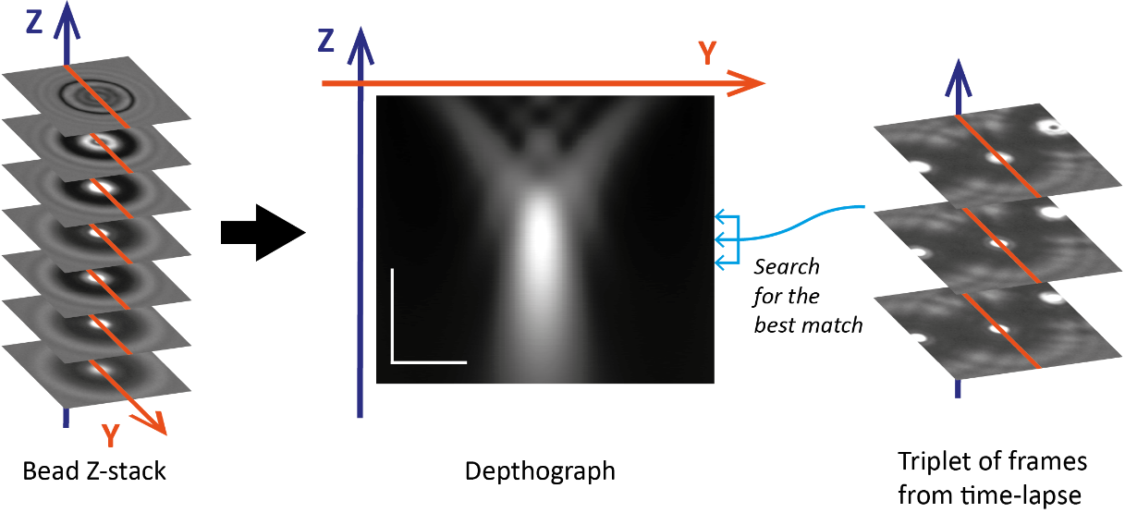

Computation and application of the Depthograph. On the left, a Z-stack used to generate the Dephtograph. In the center, an example of such Depthograph, with the depth (Z) on the vertical axis and the profiles (orange lines) on the horizontal axis (vertical scale bar: 2 µm; horizontal scale bar: 1 µm). On the right, a typical application of the Depthograph: to locate the bead along the Z-axis, one can take its profiles (orange lines) on the frames of a Z-triplet, and compare them with every row of the Depthograph to find the best match. This approach, using the fixed distance between the 3 frames (0.5 µm) as an additional information, ensure the uniqueness of the best match and improve the precision. Therefore each bead can be located within a common reference Depthograph and the distance ΔZ between the beads pinching the cortex can be computed.